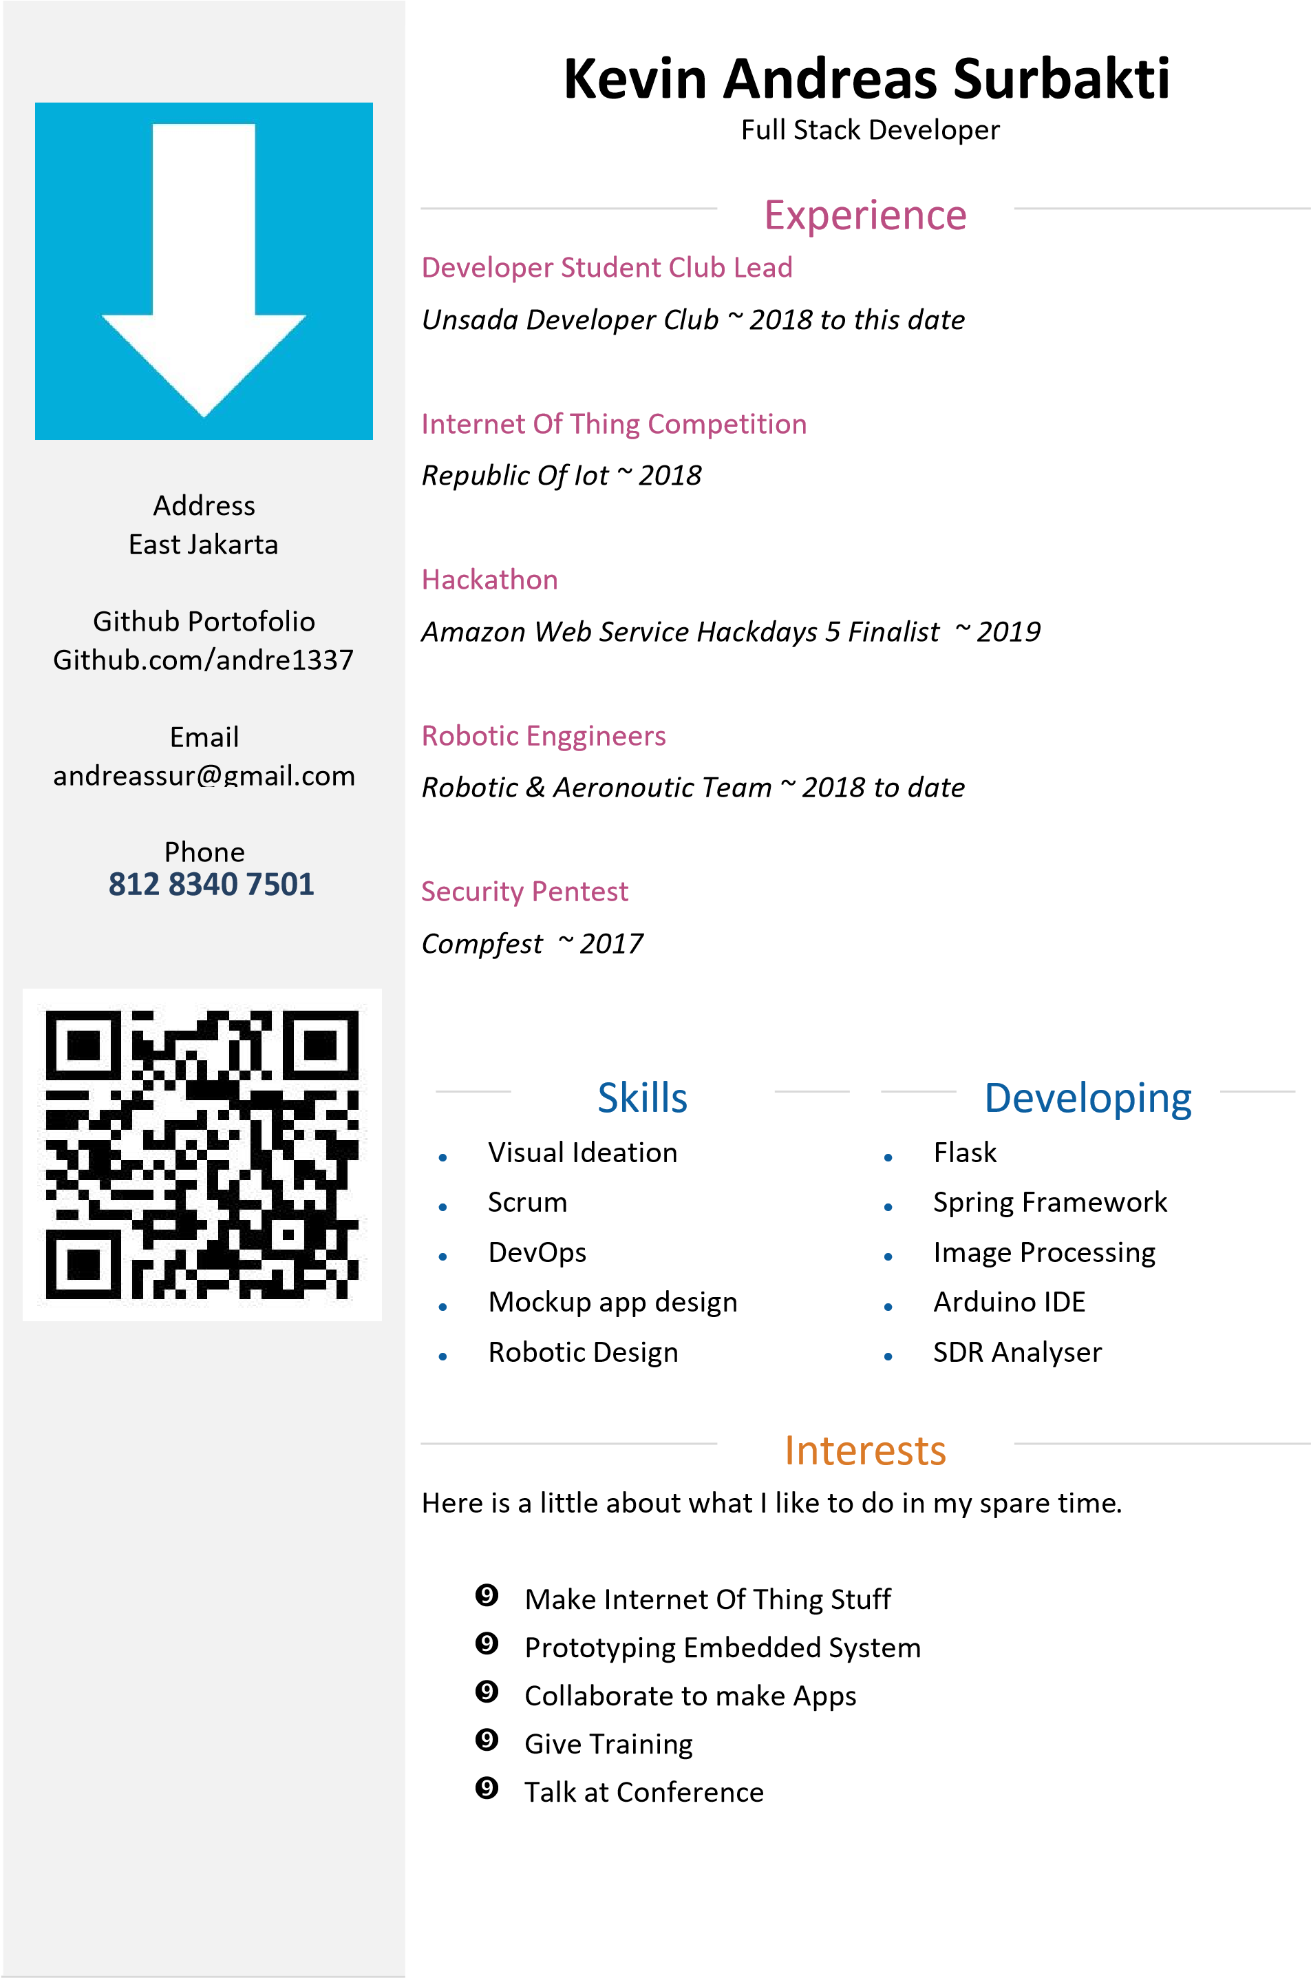

My Work Experience

Lab Assistant 2015-2018

Darma Persada University

* Make Some Syllabus practicum exercise, for Artificial Intelligence and machine learning courses
* Develop smart renewable energy monitoring (Available in Github)
* Develop payment platform for electricity bill
* Maintain Backend Network
* As Pioneer at ICT group for Universities Competition on business case application.

Full Stack Developer 2015-2017

Carina Creative Group

* Develop Automation tester for various chipset like ATmega, ESP
* Maintain Payment Platform
* Make some e-Ads using angular and Metro UI
* Maintain Rest API, with POSTMAN running on (Amazon Web Service)
* Build some extra feature, for web service using Node.js integrate with Express.js

Developer Student Club Lead 2018-2019

Darma Persada University

* Our mission is to make powerful impact application as a solution to society problem
* Training Mobile Application to student
* Make some study group
* Incubate some application to be a start-up

Robotic And Aeronautics Club Lead 2017-2018

Darma Persada University

* Build Emergency Drone for Disaster victim Identification (Available in Github)
* Build Line follower Robot
* Build Fire extinguisher robot
* Build Fixed wing robot
* Arrange team for National and international Robotic Competition

Project Experience

|  |  |  |  |  |  |  |
| --- | --- | --- | --- | --- | --- | --- |
| No | Client | City | Type Business | Period | | Result |
| Start | Finish |
| 1 | PT. Inti Semesta Permana | Bekasi | Steel | Aug-15 | Sep-15 | Storaging System and Material Labelling Software |
| 2 | PT. Niaga Sari | Bekasi | Food & Raw Material | Oct-15 | Nov-15 | Liquid Monitoring Chamber Mobile Apps |
| 3 | PT. Putra Selang | Cibitung | Architecture | Jan-16 | Jun-16 | Point Of Sales Software |
| 4 | Ardy Dan Rekan Group | Cikarang | Mining | Dec-16 | Feb-17 | Image Recognition Material Value |
| 5 | Darma Persada University | Jakarta Timur | Education | Jan-15 | Aug-19 | Smart Micro Grid System For Renewable Energy |
| 6 | Carina Creative Group | Bekasi | Supplier & Software House | Jun-15 | Feb-17 | Automation Checker Apps For Arduino And Esp |
| 7 | AMEIC And AOTS Education | Jakarta | Education | Jan-18 | Aug-19 | Line Follower Robotic For Product carry |

Certificate

